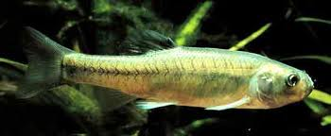
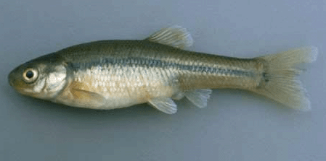

In class today, we had a chance to help out more with the Fat Head Minnow project. My classmates and I had to catch some of the Minnow’s to determine which ones where male or female. After we determined what they were, we put them in two large buckets which had labeled female and male. We put the fish in the bucket based on their gender. We all had a chance to participate more with the fish and actually get more involved than before.
After the fish were in the buckets based on their gender, we decided to put a female and male together in order to have the fish breed more often. Although or plan was going awesome at first, in the end we soon began to realize that we had more females then we had of males during this project we had an opportunity to really get more involved in the project which was fun and exciting. Having to do this project was really enjoyable.
Determinating the gender of the Minnows was the hardest part in this project because it was difficult to spot the difference between the two fish. However, if you really knew how the males and the females looked like it would really help out more. This project was entertaining and educating at the same time.
Alexa Duke
Room: 205
Grade: 7th

